**REFERENCE DETAILS FOR NEW SOFTWARE**

**MENU**

**1. Master Page**

* **Member** – Name, Father’s Name, Sex, DOB, ID proof (options)- Aadhar, Driving License, Voter ID and their number, Occupation, Reference, Reference Relationship, Address, Mobile NO (Minimum two slots), Landline no

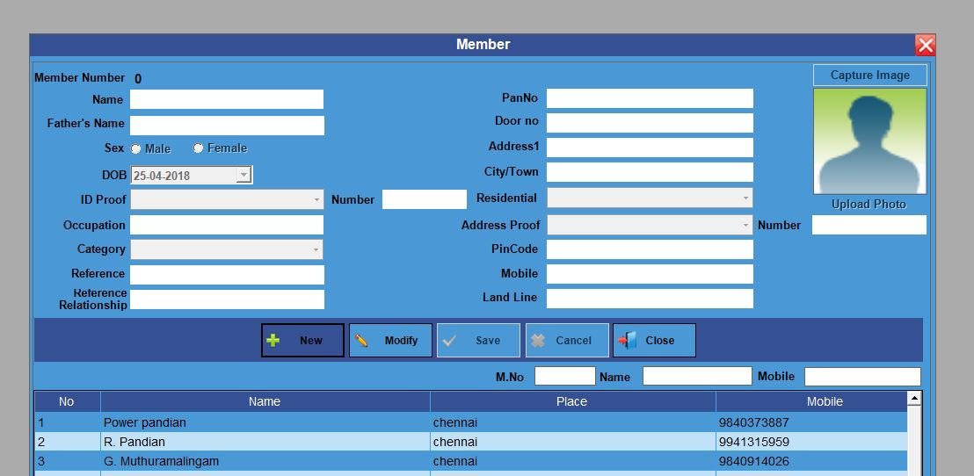

* **Interest Scheme** – Scheme Name, Interest Type- (Day/Month)  **->** save and edit option.

**2. Loan**

* Loan No, Member No, Member Name, (Address, Mobile No, Place etc.,- automatically linked form member page)
* Guarantor details- Name and address
* Document details- Document type, Doc. Details
* Loan type option –Interest/ Due

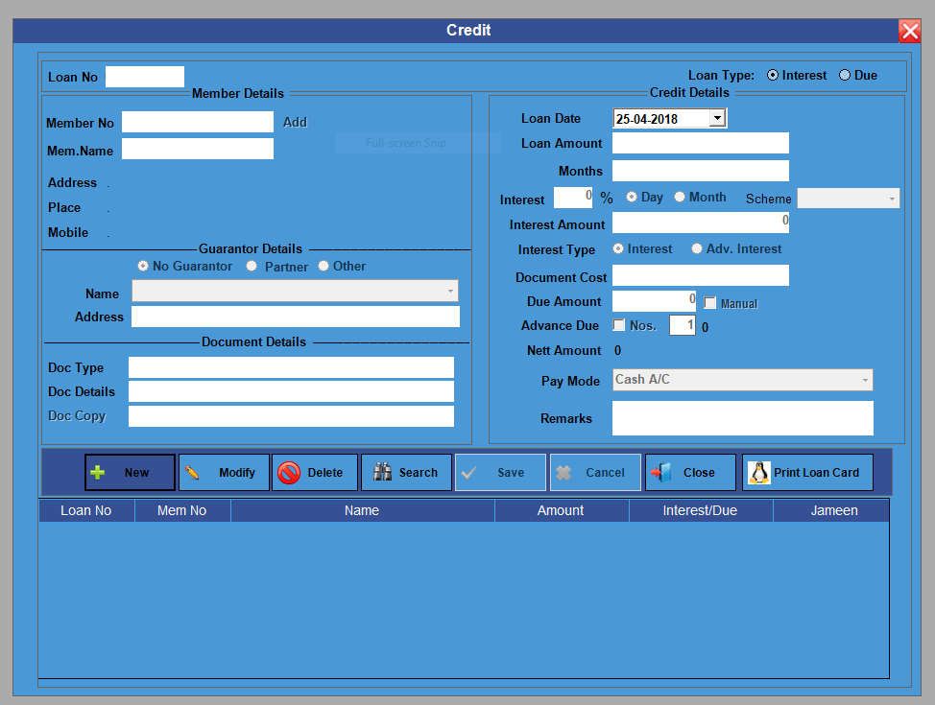

**3. Collection**

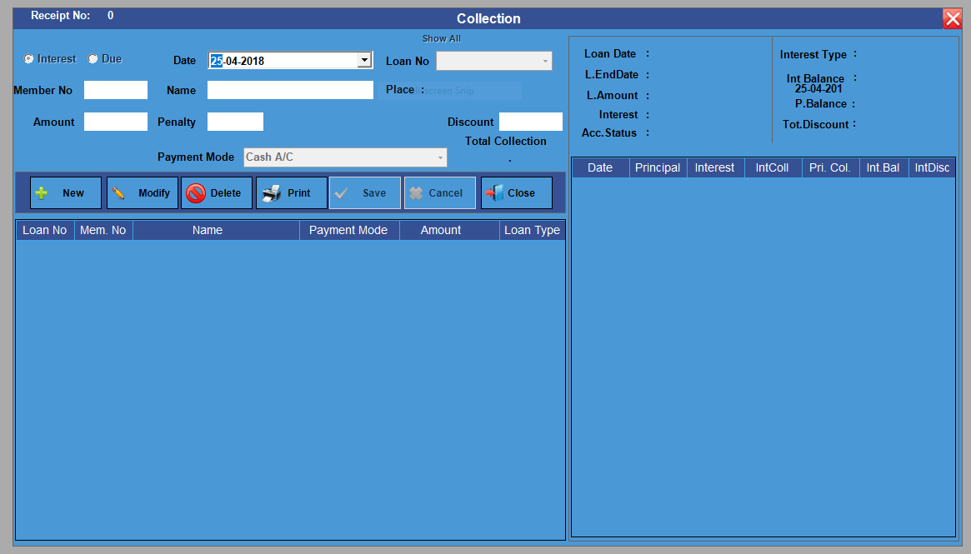

* **Interest due** -> Collection option-> Date, Loan No, Menmber No, Name, Place, (Automatically linked from source),amount, Penalty, Discount, Payment mode-> cash/Bank and other options
* **Principal** -> Date, Loan No, Member No, Name, (Automatically linked from source) Amount, payment due, interest discount.

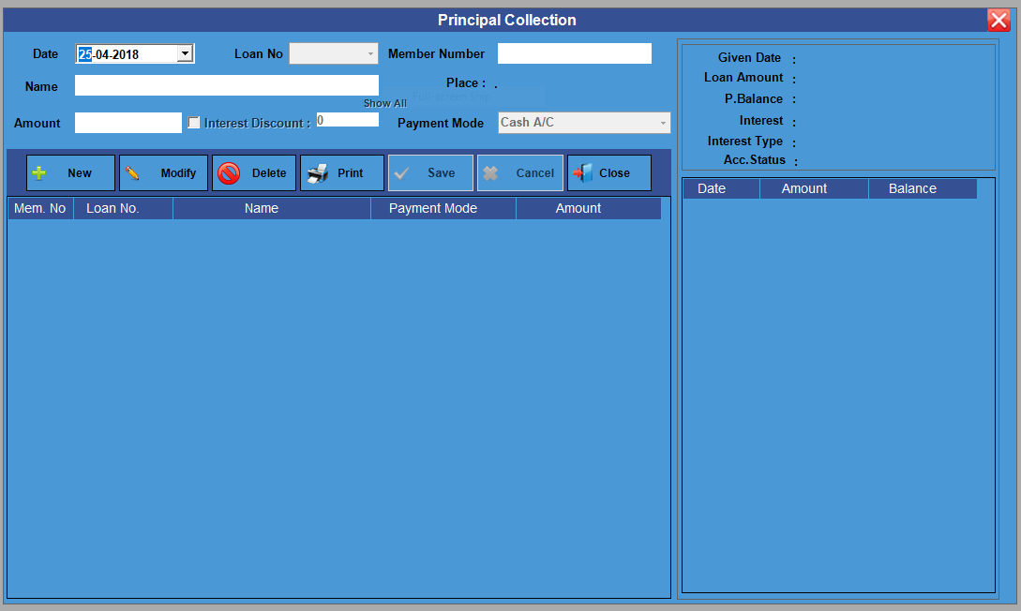

* **Interest Opening Balance** -> Member No, name, Loan No, Interest Balance.

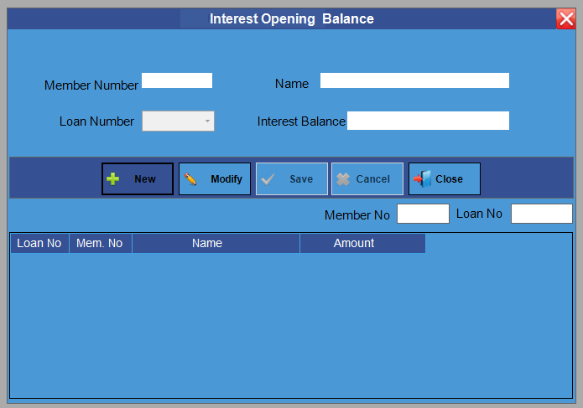

**4. Bad Debt**

* Date, Loan No, Member No, Member Name, amount. (Automatically linked from source)

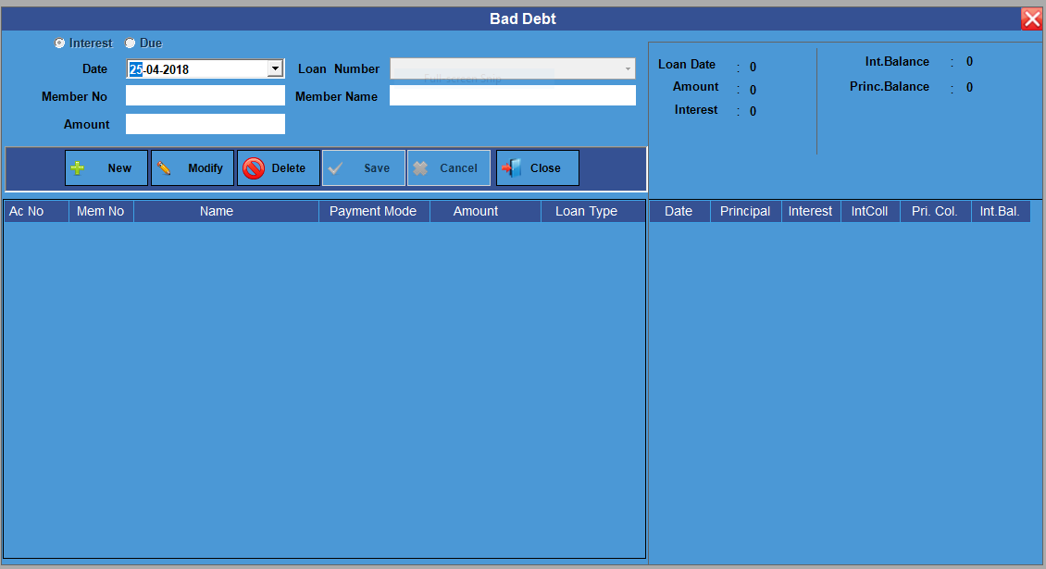

**5. Reports**

**a) List**

1. **Member List ->** Member Name, Member No, Place, Occupation, Mobile Number

(Every member’s information will be shown here)

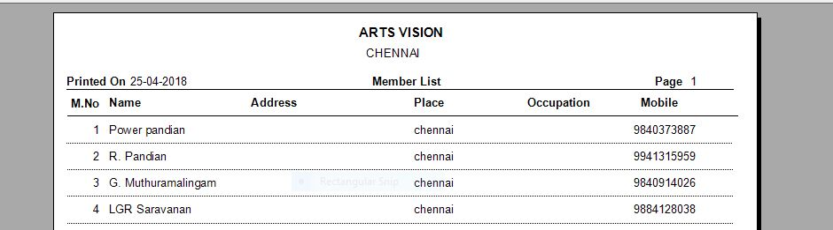

1. **Loan List ->** Pop up page will be open.

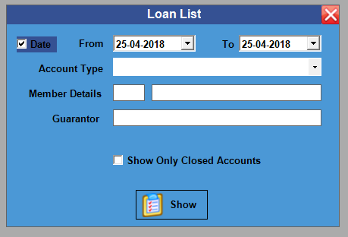

By clicking show button, we will get the information of particular member loan type, loan No, member no, name, date, amount, interest and loan type.

1. **Interest /Principal Collection List ->** Interest collected for the particular period of members.

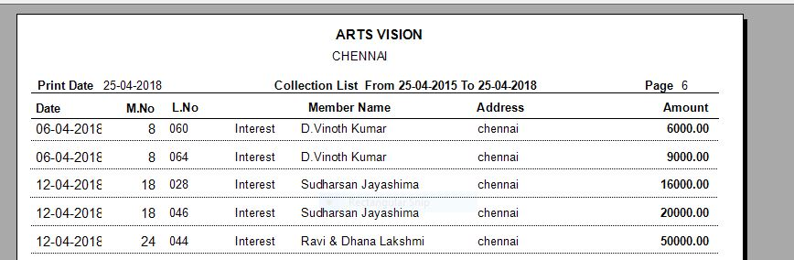

1. **Principal Collection ->** Principal collected form members with period.( from-to)

**b) Balance Reports**

1. **Balance list ->** balance list of every member with pending dates.

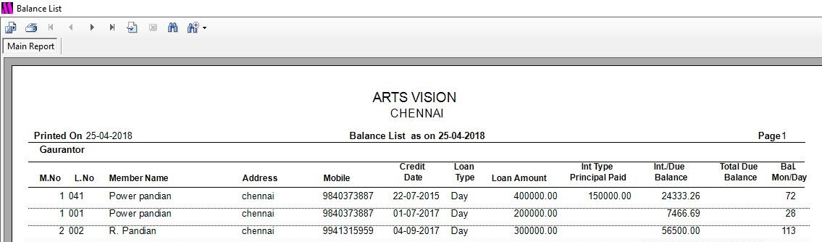

1. **Over Due balance ->** Due amount till date

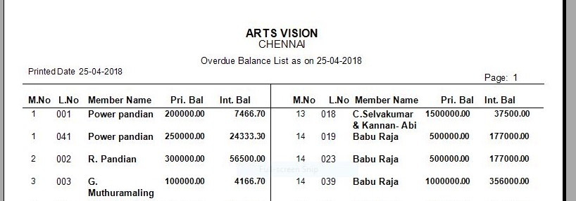

1. **Principal Balance List ->** Principal balance of every member for the particular period.

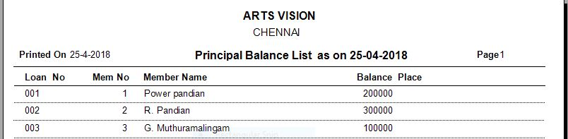

1. Collection Pre-List -> Information needed for collection.

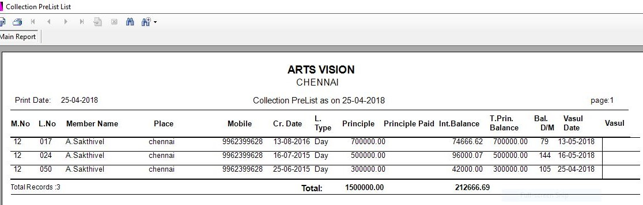

**c) Individual Details ->** Individual details with options likeDue/ Interest or both, date, member no and name. (similar to Ledger)

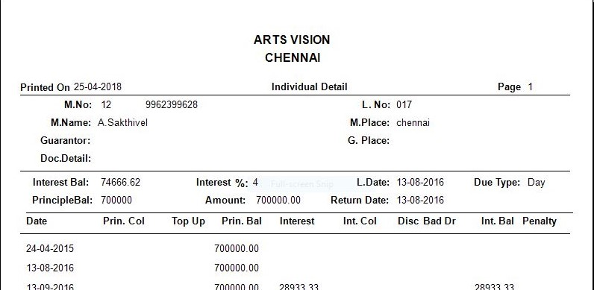

**d) Bad Debt List ->** Bad debt information with member name, member no, date of loan, amount.

**6. Analysis:**

* **Customer summary ->** Complete information of customers in Individual basis. (total of individual in respect of member number with their total amount.) Information under this category- Member No, Name, Loan amount, Pending Interest, pending Principal, Percentage, interest amount, Total interest Pending.

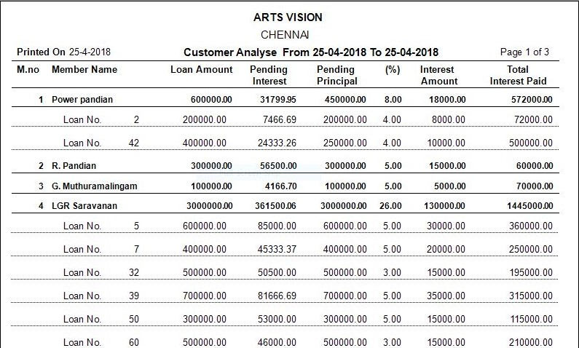

* Individual Interest Pending for the period( from - to option)
* Total monthly interest Pending (from – to option)
* Total interest received report (Every Month – From – to option)
* Other Information as per conversation. ( individual and master in excel sheet)

**7. Other settings**